Send Email Step(SES)

Objective

SendGrid is a cloud-based SMTP provider that allows you to send email without having to maintain email servers. SendGrid manages all of the technical details, from scaling the infrastructure to ISP outreach and reputation monitoring to whitelist services and real-time analytics.

UI

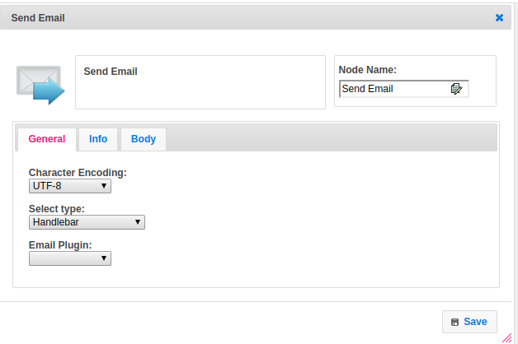

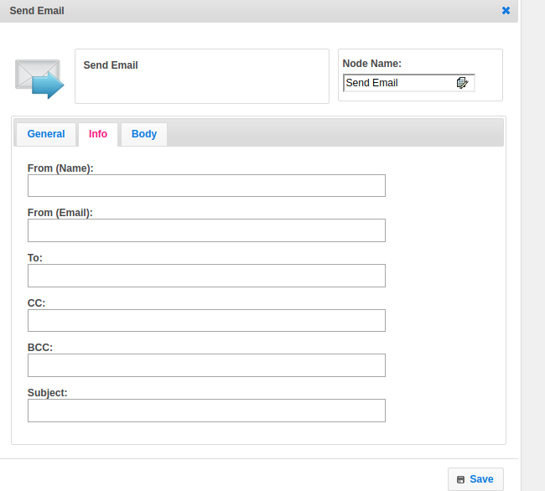

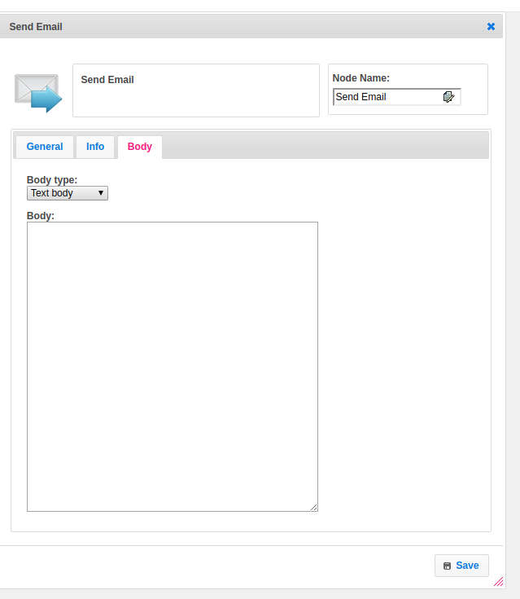

## 

## Attributes

|  |  |
| --- | --- |
| **Attributes** | **Description** |
| **1. Charecter Encoding** | Encoding schemes are often associated with a particular coded character set; UTF-8, for example, is used only to encode Unicode. ... A charset in the Java platform therefore defines a mapping between sequences of sixteen-bit UTF-16 code units (that is, sequences of chars) and sequences of bytes. |
| **2. Select Type** | Select Type used to set the value type.  Value types are two types.  1.hb-HandleBars  2.ftl-Freemarker Template Language. |
| **3. Email Plugin** | Name of the plugin. It contains the plugin configuration information. To get more information about plugin please refer the Plugin Dependence block. |
| **3. From (Name)** | Name of the sender. |
| **4. From (Mail)** | From mail address. |
| **5. To** | To mail address. |
| **6. CC** | CC(Carbon Copy ) mails. |
| **7. BCC** | BCC(Blind Carbon Copy ) mails. |
| **8. Subject** | The subject represents the mail subject |
| **9. Body type** | Body_type is having the type of body.  Supports two types of data  1.text/plain  2.text/HTML |
| **10. Body** | In the body, we can pass body data. |

## 

## Execution Description:

Plugin handler gets all properties provided by the end user and configures the plugin. Validate the to, cc, bcc and subject are empty or not. Add all step values to send email plugin. Append all the properties of the email step to the AWS SendEmailRequest class. Split the given string with default delimiter semicolon ";".Return array of a string by splitting given input with a given delimiter, If given input is null then return an empty array of strings. Check the email body-type whether it is plain text or HTML. Send Email using SendEmailRequest object which has all the required attributes.

## Plugin Dependencies:

|  |  |
| --- | --- |
| **Attributes** | **Description** |
| **1. Plugin Config Name** | Name of the plugin |
| **2. API Key** | This endpoint allows you to retrieve all API Keys that belong to the authenticated user.  The API Keys feature allows customers to be able to generate an API Key credential which can be used for authentication with the SendGrid v3 Web API. |
| **3. Secret** | Secret access keys are as the name implies secrets, like your password. For your own security, AWS doesn’t reveal your password to you if you forgot it (you’d have to set a new password). Similarly, AWS does not allow retrieval of a secret access key after its initial creation. This applies to both root secret access keys and AWS Identity and Access Management (IAM) user secret access keys. |
| **4. Region** | When you use Amazon Simple Email Service (Amazon SES), you connect to a URL that provides an endpoint for the Amazon SES API or SMTP interface. Amazon SES has endpoints in multiple AWS Regions. |

## Resource:

Please find the below link to get more information.

<https://docs.aws.amazon.com/ses/latest/APIReference/API_SendEmail.html>